Dear UTHS 1970 Classmate, 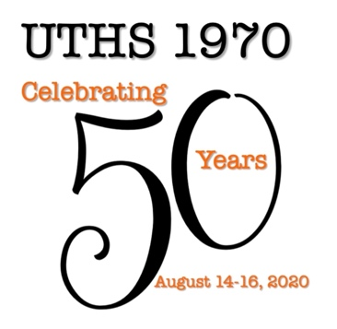

Our 50 year class reunion is scheduled on August 14-16, 2020. Attendees must pre-register by July 31, 2020. There will be no on-site registration. Check the class website for updates on activities (uths1970.com). Your registration fee ($55 per person until April 30: $60 per person May1-July 31, 2020) covers admission to the Icebreaker, UTHS campus tour, reunion dinner party, and pizza buffet.

August 14, 2020
Friday morning
An optional golf outing is scheduled at Pinnacle Country Club, Milan, IL. Earl Fox and Ross Scott will have more info available in March regarding fees and tee times.

Friday Afternoon
Meet at the designated entrance shortly before 4:00 PM for a tour of the UTHS campus. The tour will begin promptly at 4:00 PM so please be on time.

Friday evening
After dinner, gather at the East Moline American Legion to get reacquainted with classmates and guests. The doors to the Icebreaker party will open at 6:30 PM and your reunion registration materials may be picked up between 6:30 PM and 8:30 PM. UTHS faculty from 1966-1970 will be invited to join us at the Icebreaker. Light snacks will be provided and a cash bar will be available during the evening. You must be pre-registered for the reunion to attend.

August 15, 2020
Saturday evening
A dinner party is scheduled at the Holiday Inn, Rock Island. A cash bar will be available throughout the evening. Photos of grade school groups are scheduled beginning at 6:30 PM and a group photo of classmates will be taken at 6:55 PM. (You may purchase prints from the photographer which will be ready following the dinner for $15 for 5”x7” prints or $20 for 8” x 10” with payment by cash or check only.) The Quad-City DJ Company will provide entertainment throughout the evening, featuring many of our favorite “golden oldies”.
You will have your choice of five dinner options. Dinner service will begin at 7:00 PM. You may select:
- Pecan-Crusted Salmon: fresh Atlantic salmon seasoned and topped with roasted pecans and topped with a baric sauce
- Chicken Supreme: tender boneless chicken breast topped with supreme sauce served on a bed of rice
- Iowa Pork Chop: thick 10 oz. Iowa chop stuffed with apple-sage dressing and covered with sweet and sour wild mushroom sauce
- London Broil: 6 oz. marinated sirloin covered with a demi-glaze of sauteed mushrooms and onions
- Pasta Primavera: pasta dish with roasted vegetables, a light lemon cream sauce and parmesan cheese
August 16, 2020
Sunday morning
A pizza buffet is scheduled from 11:00AM - 1:00 PM at Frank’s Pizzeria, Silvis IL. A cash bar will be offered. (Frank’s does not accept checks or credit cards. There is an ATM machine in the restaurant.)

We hope to see you at the reunion!

The 50 Year Reunion Committee

